# Meeting Information

|  |  |  |
| --- | --- | --- |
| Meeting | : | Insurance & Banking Demos |
| Date | : | Tuesday, December 13, 2016 |
| Participants | : | Skriletz, Koovelimadhom, Fischer, Rana |

# Notes

## Insurance

Feedback from roadshows and other attendees

* Not impressive
* Good starting point
* Not an interesting story

“No one is going to watch the movie if the trailer is not interesting”

Every major insurance company is working with weather feeds etc. so it is not a differentiator

Hail, wind, fire, flood are of interest

Underwriting, especially in Commercial P&C, is a laborious manual process that takes weeks

Highlight the value of a Data Lake

### **Focus Areas**

**Use Case, for example, shorten the window for Commercial Underwriting**

**Flow**

* **Intro**
* **Executive overview**
* **Successive pages that tell the story**

**There will always be industry leaders (usually the large companies), but there’s ample opportunity within the small-to-midsize space**

**Telematics data, IoT, Fraud Detection (reuse from Financial Services)**

**MIT grads did something similar to LendingTree.com**

**Honeycomb diagram**

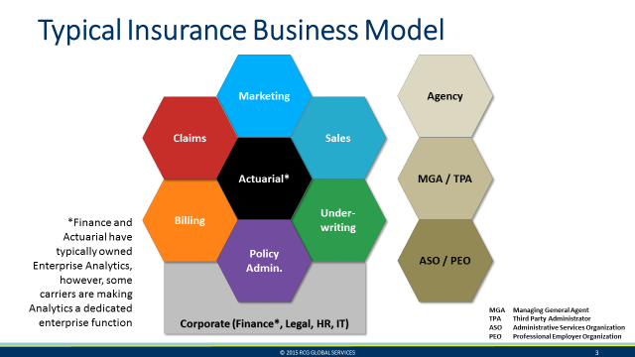

Figure – Insurance Industry Larger Picture

**Combine Sales & Marketing**

**Change Billing to Finance**

**What do we do with Policy Admin?**

**Data Science story for Actuarial?**

**Big opportunities are in Sales/Marketing, Claims and Underwriting**

**All stories are told in the Executive Overview, even though some of them are mockups**

**Each use case will have its own page/tab (one or more)**

**Underwriting**

* **Assessing risk**
* **Pricing**

**Focus on real estate property (auto will have state-wise regulations)**

* **Add hail to workflow**
* **What are the bottlenecks in the Underwriting process?**

**Focus can’t be on how to improve their business, but to showcase the “art of the possible” using Big Data and Emerging Technologies**

**If there’s one page on Underwriting, what would it be?**

* **Use MiddleOak diagram**
  + **Validate application information (data collection)**
  + **Information gathering**
  + **Rating**
  + **Underwriting**
  + **(Policy) Issuance**

### **Sketch of Underwriter UI**

* **View of book of business**
* **Drill down to individual submissions**
  + **Map**
  + **Overlay risks**
    - **Weather**
    - **Crime**
* **Underwriting**
  + **Negotiation**
  + **Price**
  + **Notes (text information that opens door to text analytics, search etc.)**
  + **Quote/Underwriting history**
  + **Claims history**
  + **Customer profitability**
* **Information (e.g. tax information, property value, ownership)**
  + **Overall**
  + **Individual**
* **Rating**
* **Issuance**

**Is there a national database for properties?**

**Loan-related information interesting to Underwriters?**

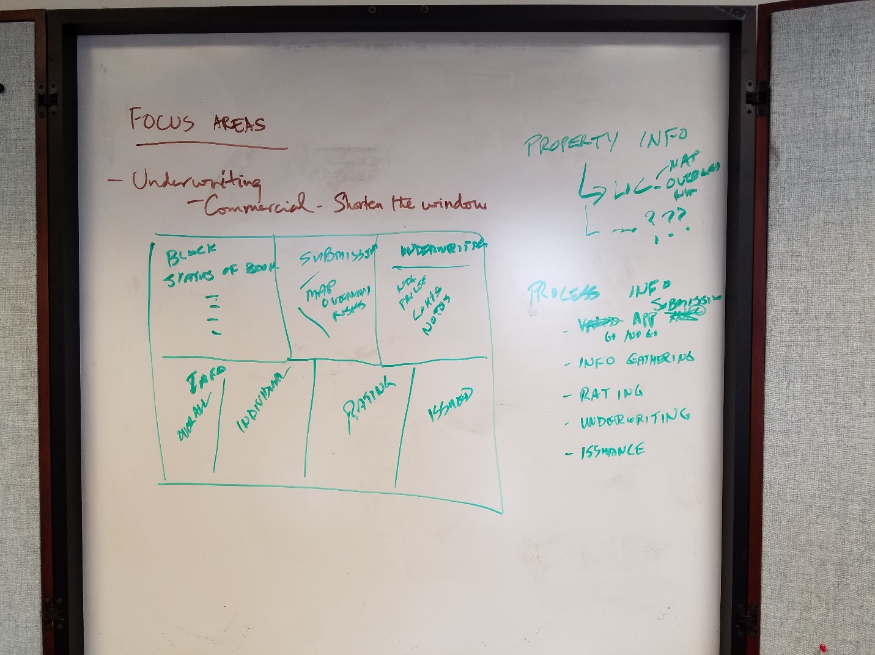

Figure – Underwriting

### **Sketch of Claims UI**

* **Prior claims (history)**
  + **Overlaps with Underwriting**
* **Spatial intelligence (what assets are at risk from a storm?)**
* **Active feeds (e.g. NOAA barometers) (before and after)**
* **Photos and videos**
* **Process**
  + **Intake**
  + **Processing**
    - **Investigations (Case Management)**
    - **Disputes**
    - **Legal**
  + **Payments**
* **Assets / Adverse weather / Claims mobilization (e.g. before a weather event)**
  + **Project losses**
* **Investigations**
* **Payments**

### **Sketch of Loss Prevention**

* **Needs to be an organizational element to react to events (e.g. who informs the fire department or police if a device reading indicates an imminent event)?**
* **Triggers**
  + **Nest thermometers**
  + **Catastrophic event predictions**
  + **Insured risks that may be impacted**
  + **Equipment maintenance**
  + **Humidity (e.g. mold risk)**
* **Screen elements**
  + **Alerts (prioritized high to low)**
  + **Triage (patterns about data from thousands of devices)**
  + **Benign**
  + **Maps and metrics**
  + **Catastrophic events**
  + **Preventive alerts for equipment**
  + **Graphic display**

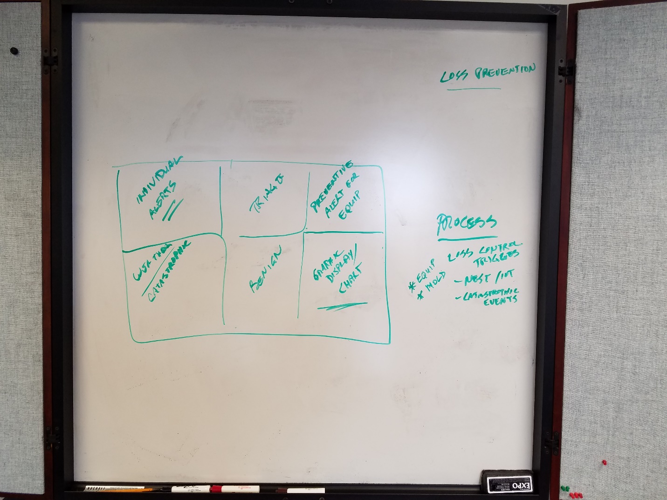

Figure – Loss Prevention

### **Claims Investigation**

Reuse from Financial Services Fraud

### Marketing & Sales

* Policies in force
* Renewal/churn
  + History
  + Claim history
* Sales volume by channel in $s and counts – should match Underwriting
  + Trending
  + Period-to-period comparisons
  + Effect of campaigns
* Customer satisfaction metrics
  + Social media and sentiment analysis
* Graphical representations
* Agent analysis
  + Hierarchy
* Call center interactions
  + Voice
  + Emails
  + Chat
  + Customer survey responses
* Call center statistics (e.g. wait times)
* Customer
  + Segmentation
  + Value
    - # policies
    - # renewals
    - # relationships
    - # referrals
  + Affinity

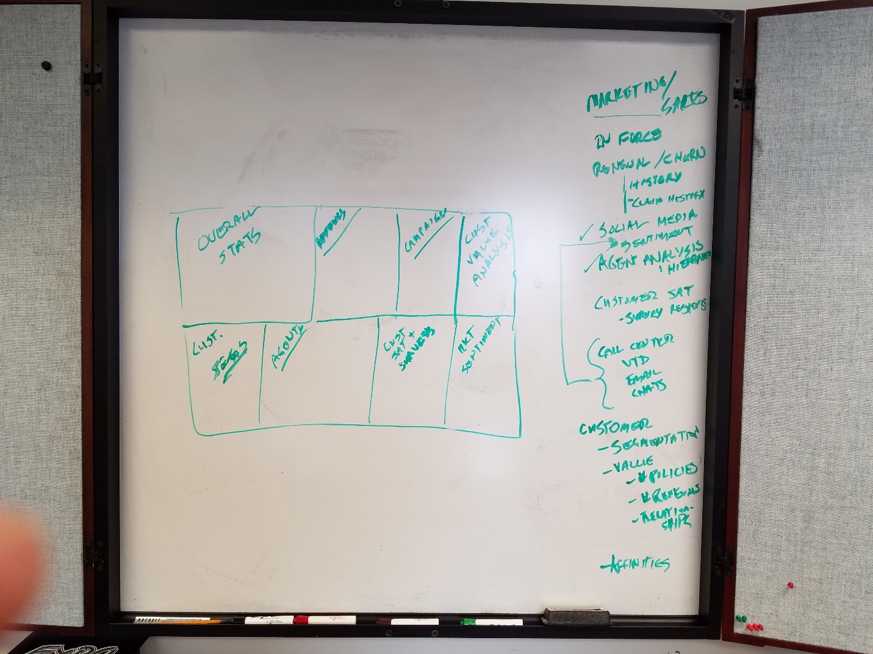

Figure – Marketing & Sales

Include Customer Value Analysis in Actuary

## Banking

Sticking to current paradigm of single use case

Current demo feedback

* Need to tell the story better, and visually
* Need to have a process view

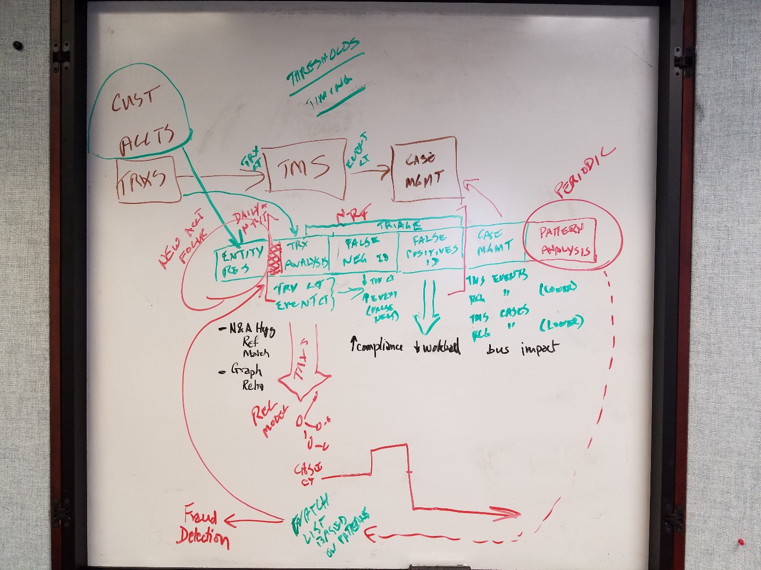

Figure – Banking Conceptual Architecture

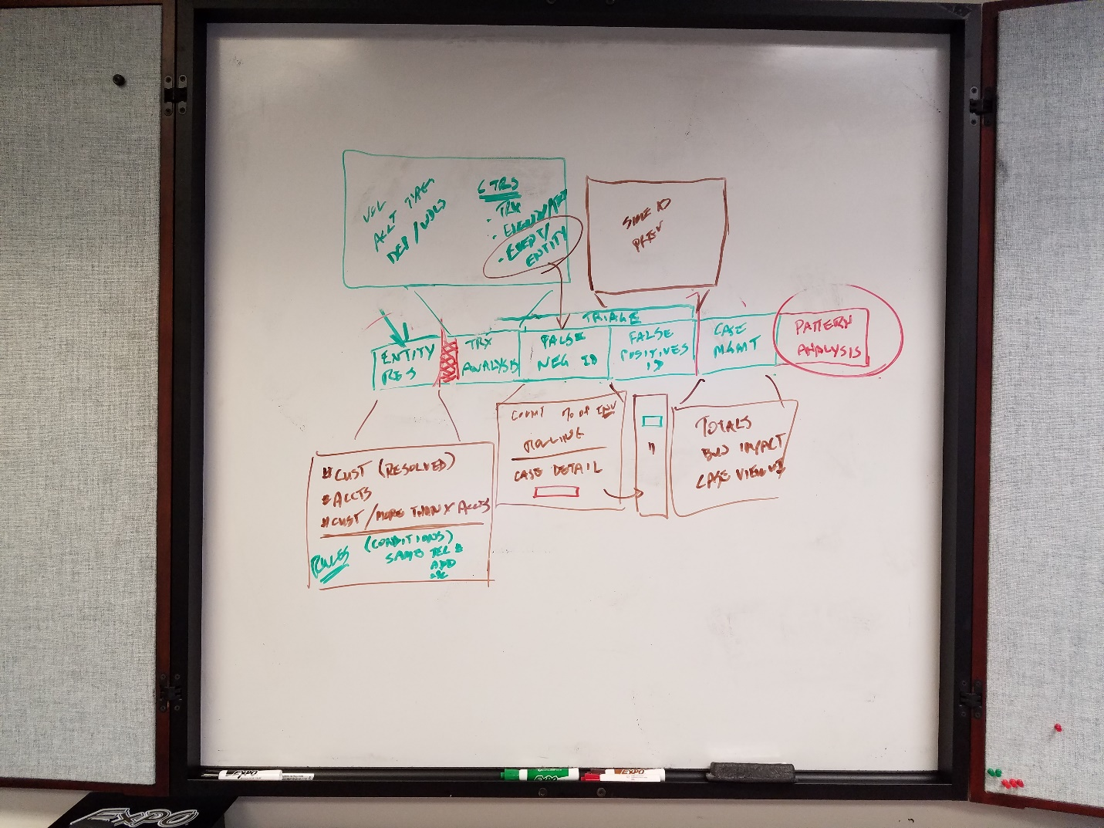

Figure – Banking Conceptual Architecture